**ASSIGNMENT OF PYTHON SESSION #5**

Q. 1. Hint:

-> Make a use of Time Module and for Loop

-> Output Should be :

Loading.

Loading..

Loading...

Loading....

Loading.....

Here it shows you 5 output but you have to print only "Loading....." in animated

form.

Ans.

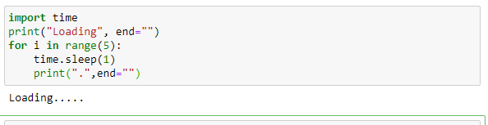

Q. 2. Difference between return and yield?

Ans. return statements are used to return a value from functions. When a return statement is encountered, the function gets terminated. There can be only one return value of a function. Multiple return statements in the same block of code are of no use, because only the first one gets executed.

When we want to make the function return many values, yield statement is used. There can be multiple yield statements in the same block of code in a function. Such a function is called a generator. Yield statement pauses the function saving all its states, and continues later on when it is called again. Generator functions are used with for loops, to return a series of values.

Q. 3. Make digital Clock and run it for 5 sec.

Output:

16:39:08

:09

:10

:11

:12

Ans.

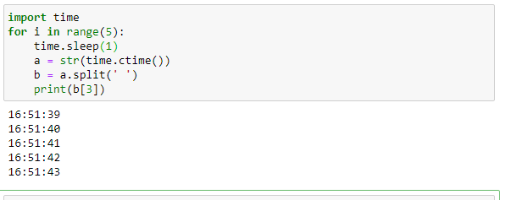

Q. 4. Add anything in tuple. Example: (1,2,3,4) -> new tuple (1,2,3,4,5)

Ans.

